**Creation of tables**

|  |  |  |
| --- | --- | --- |
| **Team Id** |  | LTVIP2025TMID29041 |
| **Project Name** |  | Calculating Family Expenses |
| **College Name** |  | Kandula Lakshumma Memorial College of Engineering for Women |

**1.Creation of family Expenses**

**1.1 . search for table**

* Go to all >in the filter search for tables
* Click on tables in system definition

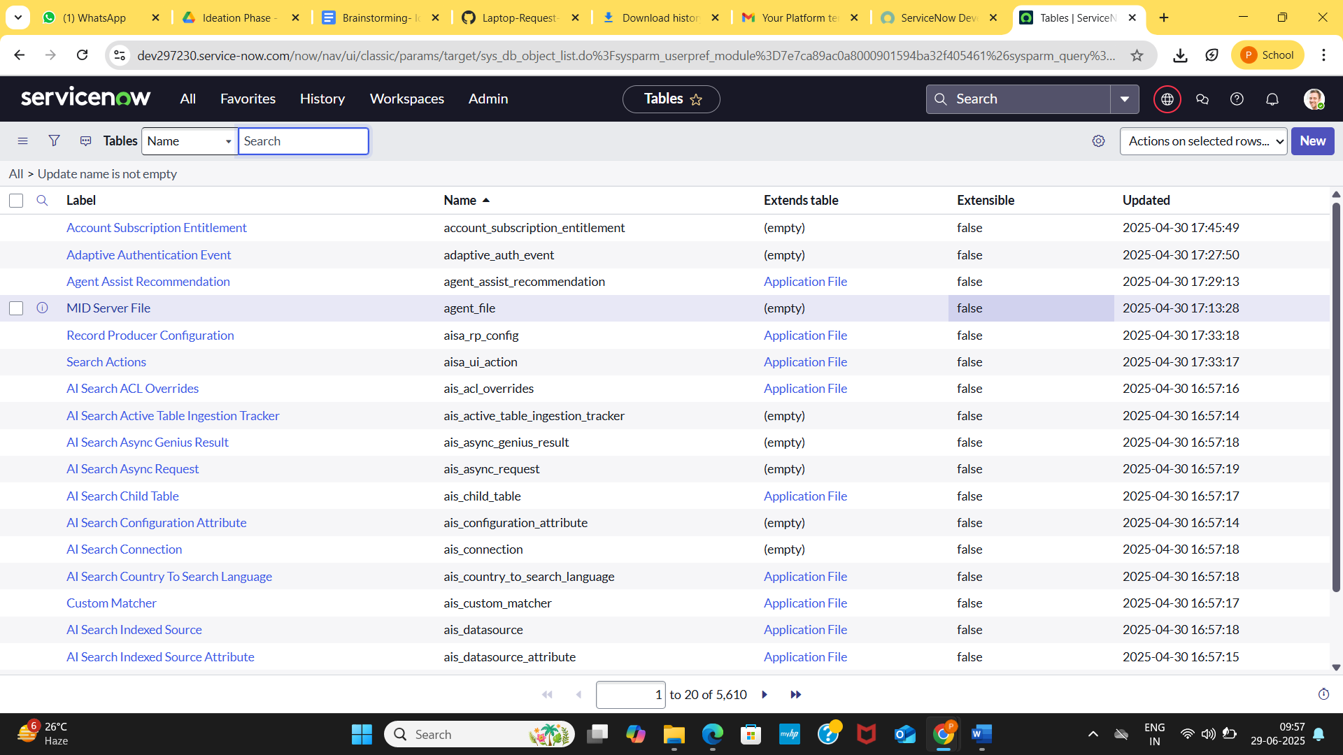

* Click on New

1.2. Enter the Details:

* Label: Family Expenses
* Name: Auto-populated
* New menu name: Family Expenditure

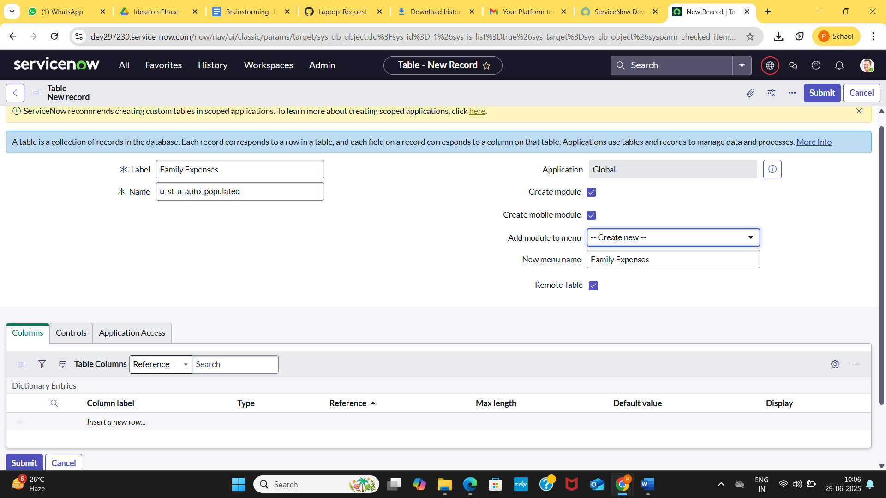

* Go to header and right click there
* Click on save